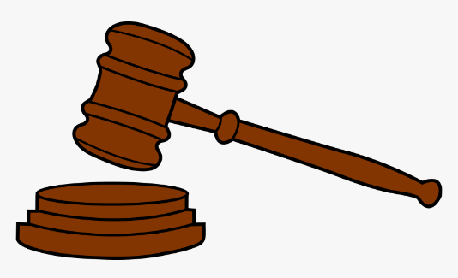
The Waukesha County Bar Association Presents:
The Judicial Roundtable

FEATURING:
Judge Bugenhagen and Judge Melvin

Where: SC-3122
When: April 17th, 2023 at 12 P.M.
Topics to be covered include:
- Criminal law focused
- Courtroom technology and how to best utilize it
- Presenting, marking, organizing exhibits in trial
- And many more

